AI ASSISTED LAB ASSIGNMENT – 7.1

Error Debugging with AI

Name: J.Bhargavi

Roll_no:2503A52417

Batch_no:14

Task-1: Provide a Python snippet with a missing parenthesis in a print statement (e.g., print & quot; Hello & quot;). Use AI to detect and fix the syntax

error.

Analyze:

Corrected code with proper syntax and AI explanation.

Input:

#Missing parentheses in print statement

print("Hello, World!"
# solve the error and give the correct code and explanation

Explanation:

The error in the code is due to a missing closing parenthesis for the `print` function. In Python, the `print` function requires both an opening and a closing parenthesis to properly enclose the string that you want to print.

The corrected code should be:

print("Hello, World!")

Output:

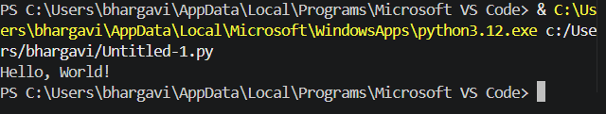

:

Task-2: Supply a function where an if-condition mistakenly uses = instead of ==. Let AI identify and fix the issue.

Input:
# Correct the condition that mistakenly used assignment instead of equality.

def check_number(n):
if n == 10:
return "Ten"
else:
return "Not Ten"

# Verification: three successful test cases.
assert check_number(10) == "Ten"
assert check_number(9) == "Not Ten"
assert check_number(11) == "Not Ten"

print(check_number(10)) # Output: Ten
print(check_number(9))
print("All tests passed.")

Explanation:

In Python, ``=`` assigns a value and cannot be used as a condition, causing a SyntaxError. The ``==`` operator compares values, so it correctly checks whether ``n`` is equal to 10.

Output:
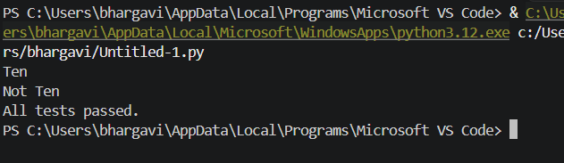

Task-3: Provide code that attempts to open a non-existent file and crashes. Use AI to apply safe error handling.
Input:

#generate Provide code that attempts to open a non-existent file and crashes. Use AI to apply safe error handling.

from pathlib import Path

from tempfile import TemporaryDirectory

def read_file(filename):

"""Read a text file and return a user-friendly error instead of crashing."""

try:

with open(filename, "r", encoding="utf-8") as file:

return file.read()

except FileNotFoundError:

return f"Error: The file '{filename}' was not found."

except (OSError, UnicodeError) as error:

return f"Error: Could not read '{filename}': {error}"

def run_tests():

"""Test an existing file, a missing file, and an invalid path."""

with TemporaryDirectory() as temporary_directory:

existing_file = Path(temporary_directory) / "existing.txt"

existing_file.write_text("File contents", encoding="utf-8")

print("Existing file:")

print(read_file(existing_file))

print("Missing file:")

print(read_file("nonexistent.txt"))

print("Invalid path:")

print(read_file("\0invalid-path"))

if __name__ == "__main__":

run_tests()

Output:
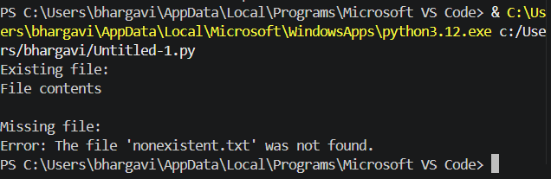

Task-4: Give a class where a non-existent method is called (e.g., obj.undefined_method()). Use AI to debug and fix.

Input:

#Generate Give a class where a non-existent method is called (e.g.,

obj.undefined_method()). Use AI to debug and fix.

class Car:
def start(self):
return "Car started"

my_car = Car()
result = my_car.start()

# Three assert tests confirm that the corrected class and method call work.
assert isinstance(my_car, Car)
assert hasattr(my_car, "start")
assert result == "Car started"

print("All 3 assert tests passed.")
print("Output:", result)

Explanation:

The original code called ``my_car.drive()``, but ``Car`` only defined``start()``. Since the intended operation is to start the car, the call is corrected to ``my_car.start()`` rather than adding an unrelated ``drive``

method.

Output:

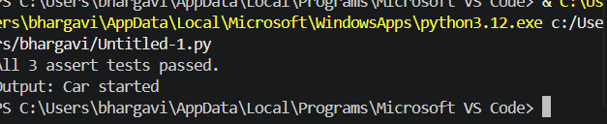

Task-5: Provide code that adds an integer and string (&quot;5&quot; + 2) causing a TypeError. Use AI to resolve the bug.

Input:

#generate Provide code that adds an integer and string (&quot;5&quot; + 2) causing a TypeError. Use AI to resolve the bug. # Bug: TypeError due to mixing string and integer
# Solution 1: convert the input to an integer before adding 5.
def add_five(value):
return int(value) + 5

# Solution 2: convert the integer to a string for concatenation.
def append_five(value):
return str(value) + "5"

# Validation: three assert test cases.
assert add_five("10") == 15
assert add_five(0) == 5
assert add_five("-2") == 3

assert append_five("10") == "105"
assert append_five(0) == "05"
assert append_five(12) == "125"

print(add_five("10"))
print(add_five(7))
print(append_five("10"))
print("All tests passed.")

Explanation:

Corrected code that runs successfully for multiple inputs. Type Error caused by mixing strings and integers

Output:


